**9. ReactJS-HOL**

**CODE:**

**IndianPlayers.js**

import React from "react";

const IndianPlayers = () => {

  const team = ["Sachin", "Sourav", "Dravid", "Sehwag", "Yuvraj", "Dhoni"];

  const oddTeam = team.filter((_, index) => index % 2 !== 0);

  const evenTeam = team.filter((_, index) => index % 2 === 0);

  const [p1, p2, p3, p4, p5, p6] = team;

  const T20players = ["Kohli", "Rohit", "Rahul"];

  const RanjiTrophyPlayers = ["Jaiswal", "Shaw", "Iyer"];

  const allPlayers = [...T20players, ...RanjiTrophyPlayers];

  return (

    <div>

      <h2>Odd Team Players</h2>

      <ul>

        {oddTeam.map((player, idx) => (

          <li key={idx}>{player}</li>

        ))}

      </ul>

      <h2>Even Team Players</h2>

      <ul>

        {evenTeam.map((player, idx) => (

          <li key={idx}>{player}</li>

        ))}

      </ul>

      <h2>All Merged Players (T20 + Ranji)</h2>

      <ul>

        {allPlayers.map((p, index) => (

          <li key={index}>{p}</li>

        ))}

      </ul>

    </div>

  );

};

export default IndianPlayers;

**ListOfPlayers.js**

import React from "react";

const ListofPlayers = () => {

  const players = [

    { name: "Virat", score: 90 },

    { name: "Rohit", score: 85 },

    { name: "Dhawan", score: 60 },

    { name: "Rahul", score: 45 },

    { name: "Pant", score: 78 },

    { name: "Jadeja", score: 55 },

    { name: "Ashwin", score: 40 },

    { name: "Bumrah", score: 92 },

    { name: "Shami", score: 66 },

    { name: "Siraj", score: 72 },

    { name: "Kuldeep", score: 68 },

  ];

  const below70 = players.filter(player => player.score < 70);

  return (

    <div>

      <h2>All Players</h2>

      <ul>

        {players.map((p, index) => (

          <li key={index}>

            {p.name} - {p.score}

          </li>

        ))}

      </ul>

      <h3>Players with Score below 70</h3>

      <ul>

        {below70.map((p, index) => (

          <li key={index}>

            {p.name} - {p.score}

          </li>

        ))}

      </ul>

    </div>

  );

};

export default ListofPlayers;

**App.js**

import React from "react";

import ListofPlayers from "./ListofPlayers";

import IndianPlayers from "./IndianPlayers";

function App() {

  const flag = true;

  return (

    <div className="App">

      <h1>Cricket App</h1>

      {flag ? <ListofPlayers /> : <IndianPlayers />}

    </div>

  );

}

export default App;

**OUTPUT:**

  const flag = false;

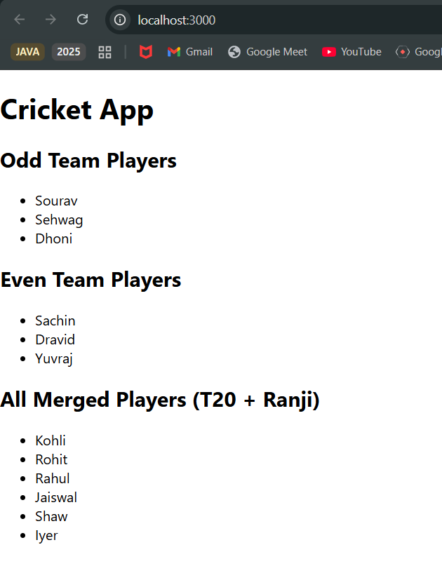

  const flag = true;

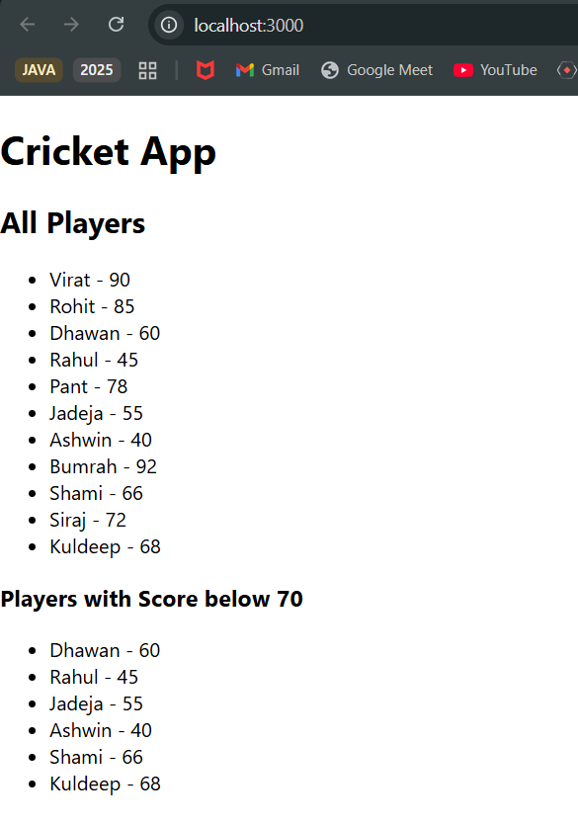

**10. ReactJS-HOL**

**CODE:**

**App.js:**

import React from "react";

import "./App.css";

function App() {

  const office = {

    name: "WeWork Co-Working",

    rent: 55000,

    address: "Indiranagar, Bangalore",

    image: "https://encrypted-tbn0.gstatic.com/images?q=tbn:ANd9GcRL84loJCSHDDdrnV137Y2MgtSFvqiDOOnPog&s"

  };

  const officeList = [

    { name: "SmartSpace", rent: 50000, address: "HSR Layout", image: "https://encrypted-tbn0.gstatic.com/images?q=tbn:ANd9GcQlZ-mF2hb41_zPUp536YlwDxfQpCaSO82jeQ&s"},

    { name: "TechHub", rent: 70000, address: "Koramangala", image: "https://encrypted-tbn0.gstatic.com/images?q=tbn:ANd9GcQ8epgNNsAPo_J3fIeQLKsenUqr8qJwebMgag&s"},

    { name: "StartupNest", rent: 60000, address: "Whitefield", image: "https://encrypted-tbn0.gstatic.com/images?q=tbn:ANd9GcTAvCq9AnmokwQQP_fsc232IDcz6nZss19nNA&s"},

  ];

  return (

    <div className="App">

      <h1>Office Space Rental App</h1>

      <h2>Featured Office</h2>

      <img src={office.image} alt="Office" width="300" />

      <p>Name: {office.name}</p>

      <p>Address: {office.address}</p>

      <p style={{ color: office.rent < 60000 ? "red" : "green" }}>

        Rent: ₹{office.rent}

      </p>

      <hr />

      <h2>Available Office Listings</h2>

      {officeList.map((item, index) => (

        <div key={index} style={{ border: "1px solid gray", margin: "10px", padding: "10px" }}>

          <img src={item.image} alt={item.name} width="200" />

          <p><strong>Name:</strong> {item.name}</p>

          <p><strong>Address:</strong> {item.address}</p>

          <p style={{ color: item.rent < 60000 ? "red" : "green" }}>

            <strong>Rent:</strong> ₹{item.rent}

          </p>

        </div>

      ))}

    </div>

  );

}

export default App;

**OUTPUT:** 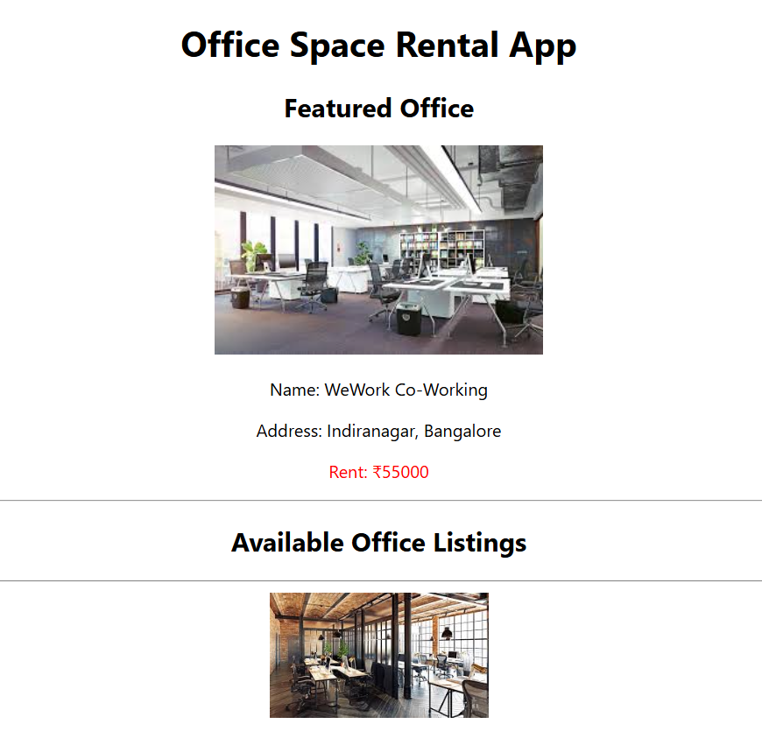

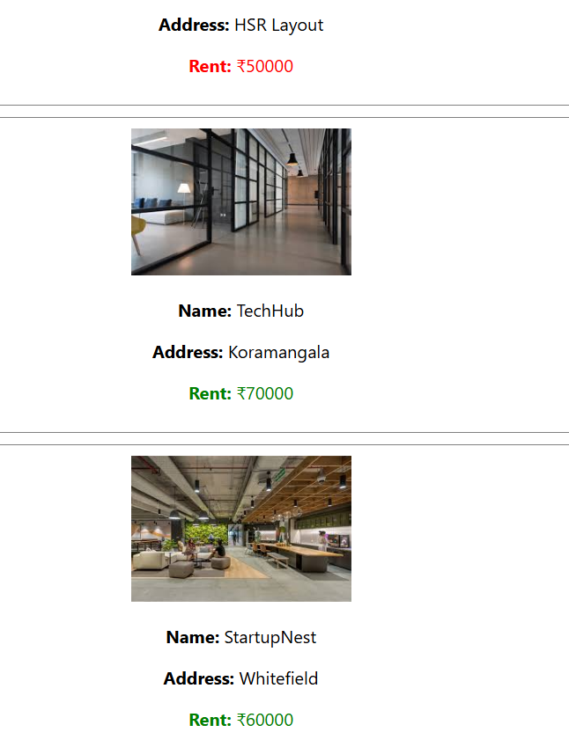

**11. ReactJS-HOL**

**CODE:**

CurrencyConvertor.js

import React, { useState } from "react";

const CurrencyConvertor = () => {

  const [rupees, setRupees] = useState("");

  const [euros, setEuros] = useState("");

  const handleSubmit = (e) => {

    e.preventDefault();

    const converted = (parseFloat(rupees) / 90).toFixed(2);

    setEuros(converted);

  };

  return (

    <div>

      <form onSubmit={handleSubmit}>

        <label>

          Indian Rupees: ₹{" "}

          <input

            type="number"

            value={rupees}

            onChange={(e) => setRupees(e.target.value)}

          />

        </label>

        <button type="submit" style={{ marginLeft: "10px" }}>

          Convert

        </button>

      </form>

      {euros && (

        <p>

          <strong>Converted Amount in Euros:</strong> €{euros}

        </p>

      )}

    </div>

  );

};

export default CurrencyConvertor;

**App.js**

import React, { useState } from "react";

import CurrencyConvertor from "./CurrencyConvertor";

function App() {

  const [count, setCount] = useState(0);

  const handleIncrease = () => {

    increment();

    sayHello();

  };

  const increment = () => {

    setCount(count + 1);

  };

  const decrement = () => {

    setCount(count - 1);

  };

  const sayHello = () => {

    console.log("Hello! This is a static message.");

  };

  const sayWelcome = (message) => {

    alert(message);

  };

  const handleClick = (e) => {

    alert("I was clicked");

    console.log("Synthetic Event:", e);

  };

  return (

    <div className="App" style={{ padding: "20px", fontFamily: "Arial" }}>

      <h1>Event Examples App</h1>

      <h2>Counter</h2>

      <p>Value: {count}</p>

      <button onClick={handleIncrease}>Increase</button>

      <button onClick={decrement} style={{ marginLeft: "10px" }}>

        Decrease

      </button>

      <h2>Say Welcome</h2>

      <button onClick={() => sayWelcome("Welcome!")}>Say Welcome</button>

      <h2>Synthetic Event Example</h2>

      <button onClick={handleClick}>Click Me</button>

      <h2>Currency Convertor</h2>

      <CurrencyConvertor />

    </div>

  );

}

export default App;

**OUTPUT:**

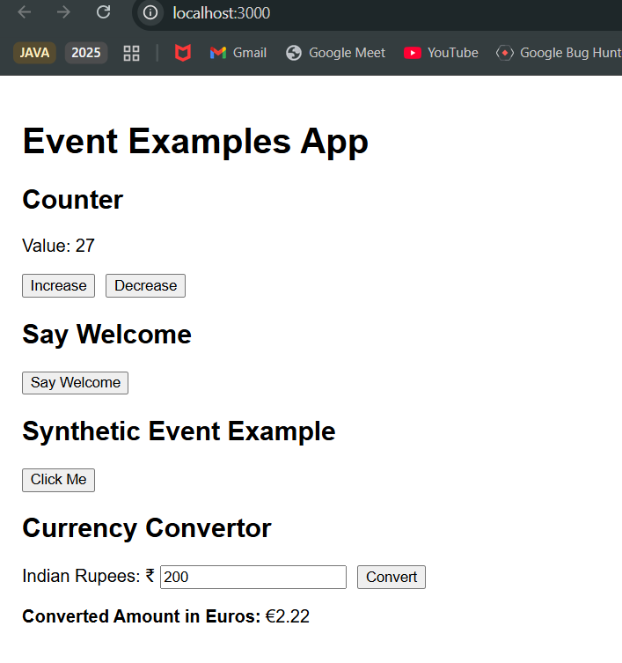

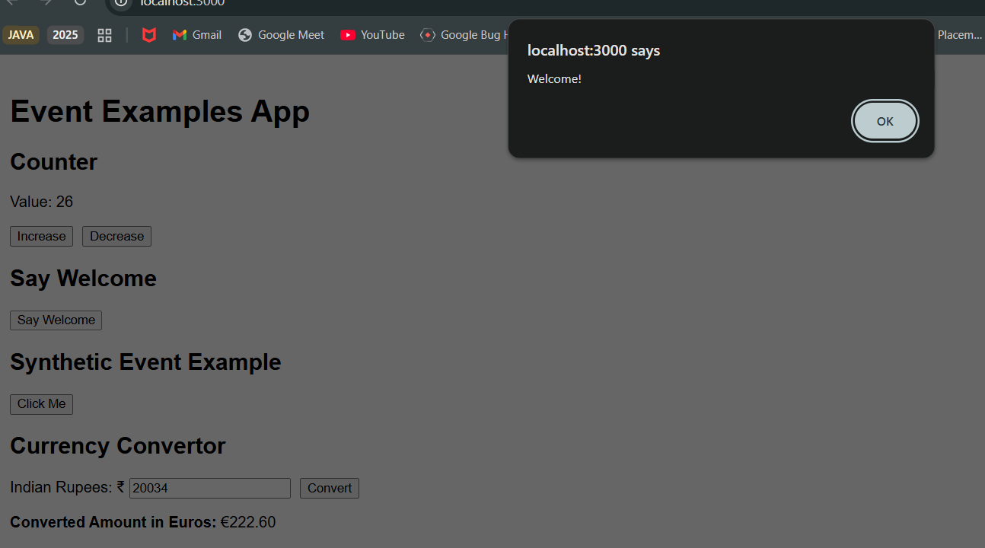

**12. ReactJS-HOL**

**CODE:**

**FlightDetails.js**

import React from "react";

const FlightDetails = () => {

  return (

    <div>

      <h2>Available Flights</h2>

      <ul>

        <li>Flight 101 - Bangalore to Delhi - ₹5500</li>

        <li>Flight 202 - Chennai to Mumbai - ₹4800</li>

        <li>Flight 303 - Hyderabad to Kolkata - ₹6200</li>

      </ul>

    </div>

  );

};

export default FlightDetails;

**GuestPage.js**

import React from "react";

import FlightDetails from "./FlightDetails";

const GuestPage = ({ onLogin }) => {

  return (

    <div>

      <h1>Welcome, Guest </h1>

      <FlightDetails />

      <button onClick={onLogin}>Login to Book Tickets</button>

    </div>

  );

};

export default GuestPage;

**UserPage.js**

import React from "react";

import FlightDetails from "./FlightDetails";

const UserPage = ({ onLogout }) => {

  return (

    <div>

      <h1>Welcome, User </h1>

      <FlightDetails />

      <h3>Book Your Ticket</h3>

      <form>

        <label>

          Passenger Name: <input type="text" placeholder="Enter name" />

        </label>

        <br /><br />

        <label>

          Flight Number: <input type="text" placeholder="e.g., 101" />

        </label>

        <br /><br />

        <button type="submit">Book Ticket</button>

      </form>

      <br />

      <button onClick={onLogout}>Logout</button>

    </div>

  );

};

export default UserPage;

**App.js**

import React, { useState } from "react";

import GuestPage from "./GuestPage";

import UserPage from "./UserPage";

function App() {

  const [isLoggedIn, setIsLoggedIn] = useState(false);

  const handleLogin = () => {

    setIsLoggedIn(true);

  };

  const handleLogout = () => {

    setIsLoggedIn(false);

  };

  return (

    <div className="App" style={{ padding: "20px", fontFamily: "Arial" }}>

      <h1> Ticket Booking App</h1>

      {isLoggedIn ? (

        <UserPage onLogout={handleLogout} />

      ) : (

        <GuestPage onLogin={handleLogin} />

      )}

    </div>

  );

}

export default App**;**

**OUTPUT:**

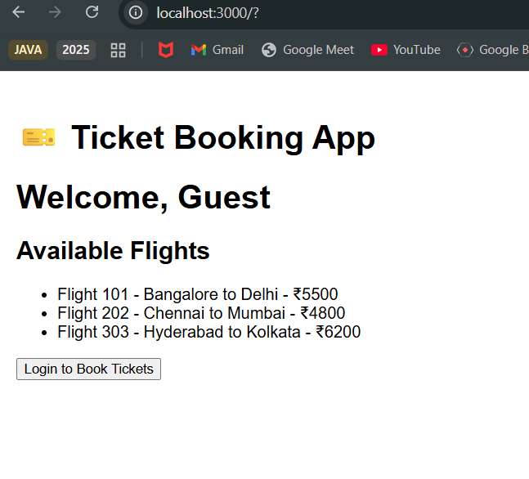

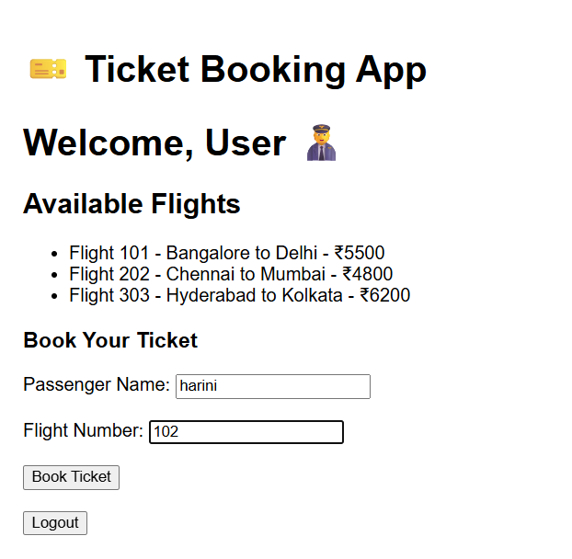

**13. ReactJS-HOL**

**CODE:**

**App.js**

import React, { useState } from "react";

import BookDetails from "./BookDetails";

import BlogDetails from "./BlogDetails";

import CourseDetails from "./CourseDetails";

function App() {

  const [view, setView] = useState("book");

  return (

    <div className="App" style={{ padding: "20px", fontFamily: "Arial" }}>

      <h1>📖 BloggerApp - Conditional Rendering</h1>

      <div>

        <button onClick={() => setView("book")}>Show Book</button>

        <button onClick={() => setView("blog")}>Show Blog</button>

        <button onClick={() => setView("course")}>Show Course</button>

        <button onClick={() => setView("none")}>Clear</button>

      </div>

      <hr />

      {(() => {

        if (view === "book") return <BookDetails />;

        else if (view === "blog") return <BlogDetails />;

        else if (view === "course") return <CourseDetails />;

        else return <p>Please select a section to display.</p>;

      })()}

    </div>

  );

}

export default App;

**CourseDetails.js**

import React from "react";

const CourseDetails = () => {

  return (

    <div>

      <h2> Course Details</h2>

      <p>Name: React Developer Bootcamp</p>

      <p>Instructor: John Doe</p>

      <p>Duration: 30 hours</p>

    </div>

  );

};

export default CourseDetails;

**BlogDetails.js**

import React from "react";

const BlogDetails = () => {

  return (

    <div>

      <h2>Blog Details</h2>

      <p>Title: Learning React</p>

      <p>Author: Sumithra R</p>

      <p>Date: July 2025</p>

    </div>

  );

};

export default BlogDetails;

**BookDetails.js**

import React from "react";

const BookDetails = () => {

  return (

    <div>

      <h2>Book Details</h2>

      <p>Title: React Made Easy</p>

      <p>Author: Sumithra R</p>

      <p>Pages: 250</p>

    </div>

  );

};

export default BookDetails;

**OUTPUT:**

